**Chapter 5**

**Multiple Integration**

**5.2 Double Integrals over General Regions**

**Section Exercises**

**In the following exercises, specify whether the region is of Type I or Type II.**

61. Find the average value of the function  on the region graphed in the previous exercise.

Answer: 

63. The region  bounded by  as given in the following figure.

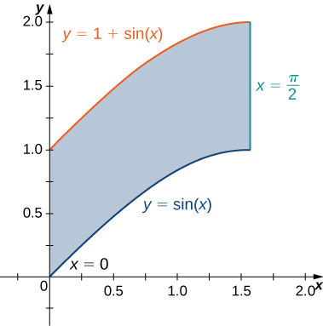

Answer: Type I but not Type II

65. Find the area of the region  given in the previous exercise.

Answer: 

67. Find the volume of the solid under the graph of the function  and above the region in the figure in the previous exercise.

Answer: 

69. Find the volume of the solid under the graph of the function  and above the region in the figure from the previous exercise.

Answer: 

71. The region  bounded by  and  as given in the following figure.

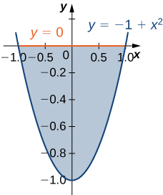

Answer: Type I and Type II

73. Let be the region bounded by the curves of equations  and  and the *-*axis. Explain why  is neither of Type I nor II.

Answer: The region  is not of Type I: it does not lie between two vertical lines and the graphs of two continuous functions  and  The region  is not of Type II: it does not lie between two horizontal lines and the graphs of two continuous functions  and 

In the following exercises, evaluate the double integral  over the region 

75.  and 

Answer: 

77.  and 

Answer: 

79.  and  is the triangular region with vertices 

Answer: 

**Evaluate the iterated integrals.**

81. 

Answer: 

83. 

Answer: 

85. 

Answer: 

87. Let be the region bounded by    and the -axis.

1. Show that  by dividing  into two regions of Type I.
2. Evaluate the integral 

Answer: a. Answers may vary; b. 

89. Let  be the region bounded by  and 

1. Show that  by dividing the region  into two regions of Type II, where .
2. Evaluate the integral 

Answer: a. Answers may vary; b. 

91. The region  bounded by  and  is shown in the following figure. Find the area  of the region 

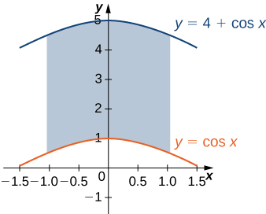

Answer: 

93. Let  be the regionbounded by  and the -axis. Find the area  of the region 

Answer: 

95. Find the average value of the function  on the triangular region with vertices  and 

Answer: 

**In the following exercises, change the order of integration and evaluate the integral.**

97. 

Answer: 

99. 

Answer: 

101. The region  is given in the following figure. Evaluate the double integral  by using the easier order of integration.

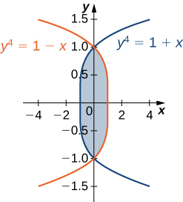

Answer: 

103. Find the volume of the solid under the plane  and above the region determined by  and 

Answer: 

105. Find the volume of the solid under the surface  and above the plane region bounded by  and 

Answer: 

107. Let  be a positive, increasing, and differentiable function on the interval  and let  be a positive real number. Show that the volume of the solid under the surface  and above the region bounded by  and  is given by 

Answer: This is a proof; therefore, no answer is provided.

109. Find the volume of the solid situated in the first octant and bounded by the planes  

Answer: 

111. Find the volume of the solid bounded by the planes  

Answer: 

113. Let  be the solids situated in the first octant under the planes  and  respectively, and let  be the solid situated between 

1. Find the volume of the solid 
2. Find the volume of the solid 
3. Find the volume of the solid by subtracting the volumes of the solids 

Answer: a.  b.  c. 

115. Let  and be the solids situated in the first octant under the plane  and bounded by the cylinder  respectively.

1. Find the volume of the solid 
2. Find the volume of the solid 
3. Find the volume of the solid  situated between  and  by subtracting the volumes of the solids  and 

Answer: a.  b.  c. 

117. **[T]** The region bounded by the curves  is shown in the following figure. Use a graphing calculator or CAS to find the *x*-coordinates of the intersection points of the curves and to determine the area of the region Round your answers to six decimal places.

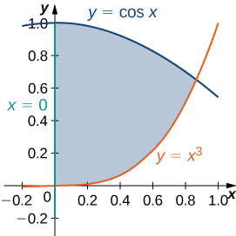

Answer:  

119. Consider  two random variables of probability densities  and  respectively. The random variables  are said to be independent if their joint density function is given by  At a drive-thru restaurant, customers spend, on average,  minutes placing their orders and an additional  minutes paying for and picking up their meals. Assume that placing the order and paying for/picking up the meal are two independent events  and  If the waiting times are modeled by the exponential probability densities

 and 

respectively, the probability that a customer will spend less than 6 minutes in the drive-thru line is given by  where  Find  and interpret the result.

Answer:  there is a  chance that a customer will spend  minutes in the drive-thru line.

121. **[T]** Show that the area of the lunes of Alhazen, the two blue lunes in the following figure, is the same as the area of the right triangle *ABC*. The outer boundaries of the lunes are semicircles of diameters  respectively, and the inner boundaries are formed by the circumcircle of the triangle 

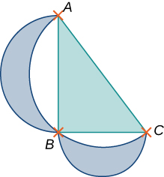

Answer: This is a proof; therefore, no answer is provided.

This file is copyright 2016, Rice University. All Rights Reserved.